**ER diagram of Library Management System**

* Difficulty Level : [Easy](https://www.geeksforgeeks.org/easy/)
* Last Updated : 19 Sep, 2022

• Read

• Discuss

[ER Diagram](https://www.geeksforgeeks.org/introduction-of-er-model/) is known as Entity-Relationship Diagram, it is used to analyze  the structure of the Database. It shows relationships between entities and their attributes. An ER Model provides a means of communication.

The Library Management System database keeps track of readers with the following considerations –

* The system keeps track of the staff with a single point authentication system comprising login Id and password.
* Staff maintains the book catalog with its ISBN, Book title, price(in INR), category(novel, general, story), edition, author Number and details.
* A publisher has publisher Id, Year when the book was published, and name of the book.
* Readers are registered with their user_id, email, name (first name, last name), Phone no (multiple entries allowed), communication address. The staff keeps track of readers.
* Readers can return/reserve books that stamps with issue date and return date. If not returned within the prescribed time period, it may have a due date too.
* Staff also generate reports that has readers id, registration no of report, book no and return/issue info.

[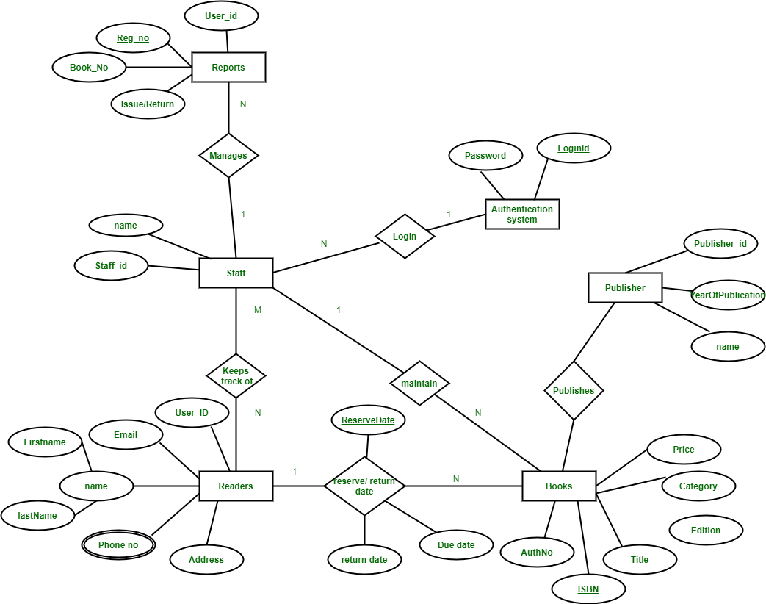](https://media.geeksforgeeks.org/wp-content/uploads/20200923150244/ER1.png)

*ER Diagram of Library Management System*

This Library ER diagram illustrates key information about the Library, including entities such as staff, readers, books, publishers, reports, and authentication system. It allows for understanding the relationships between entities.

**Entities and their Attributes –**

* **Book Entity:**It has authno, isbn number, title, edition, category, price. ISBN is the Primary Key for Book Entity.
* **Reader Entity :**It has UserId, Email, address, phone no, name. Name is composite attribute of firstname and lastname. Phone no is multi valued attribute. UserId is the Primary Key for Readers entity.
* **Publisher Entity :**It has PublisherId, Year of publication, name. PublisherID is the Primary Key.
* **Authentication System Entity :**It has LoginId and password with LoginID as Primary Key.
* **Reports Entity :**It has UserId, Reg_no, Book_no, Issue/Return date. Reg_no is the Primary Key of reports entity.
* **Staff Entity :**It has name and staff_id with staff_id as Primary Key.
* **Reserve/Return Relationship Set :**It has three attributes: Reserve date, Due date, Return date.

[**Relationships**](https://www.geeksforgeeks.org/attributes-to-relationships-in-er-model/)**between Entities –**

* A reader can reserve N books but one book can be reserved by only one reader. The relationship 1:N.
* A publisher can publish many books but a book is published by only one publisher. The relationship 1:N.
* Staff keeps track of readers. The relationship is M:N.
* Staff maintains multiple reports. The relationship 1:N.
* Staff maintains multiple Books. The relationship 1:N.
* Authentication system provides login to multiple staffs. The relation is 1:N.